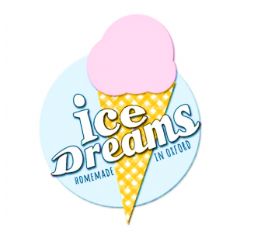

**After 8**

**Cream, milk, egg yolks,** sugar, **After 8 chocolates**

**Apple Crumble**

**Milk, cream, egg yolks,** Bramley Apples, **flour, butter,** sugar, corn syrup, vanilla pod

**Blueberry Cheesecake**

**Mascarpone,** blueberries, sugar, **sour cream, cream,** lemon zest, **cornflour,** Cassis, salt

**Chilli, Ginger & Lemongrass**

**Cream, milk, egg yolks,** sugar, fresh chilli, fresh ginger, lemongrass, salt

**Chocolate Orange**

**Cream, milk, egg yolks,** sugar, **cocoa, 70% dark chocolate,** orange juice, zest & extract

**Coffee**

**Cream, milk, egg yolks,** sugar, coffee

**Ferrero Rocher**

**Cream, milk, egg yolks,** sugar, **Nutella, Ferrero Rocher chocolates**

**Hokey Pokey**

**Milk, cream, egg yolks**, sugar, honeycomb (syrup, sugar, bicarbondate of soda),

corn syrup,vanilla pod

**Lemon Curd**

**Egg yolks,** lemons, **cream,** sugar

**Raspberry Ripple**

Raspberries, **milk, cream, egg yolks,** sugar, corn syrup, vanilla pod

**Salted Caramel**

**Cream, milk, eggs,** sugar, Fleur de Sel (flaky sea salt), vanilla extract

**Stem Ginger**

**Cream, eggs,** sugar, cornflour, stem ginger & syrup, vanilla extract

**Strawberries & Cream**

Strawberries, **cream**, sugar, balsamic vinegar

**Vanilla**

**Cream, milk, egg yolks,** sugar, vanilla pod